Modeling Mental Health Treatment-Seeking Behavior to Inform Workplace Support Strategies

Introduction - Tania
Workplace mental health is a critical public health concern, impacting both individual well-being and organizational productivity. In the United States, one in five adults experiences a mental health condition, and nearly half will encounter a mental health disorder during their lifetime [2]. Untreated conditions carry significant economic costs, with projected productivity losses of $6 trillion for employers by 2030 [1].
Despite this, many employees do not seek support due to stigma, limited awareness, and insufficient workplace resources. Evidence shows that organizations fostering psychologically healthy environments—through supportive leadership, accessible mental health programs, and stigma-reducing policies—see measurable improvements in both employee well-being and organizational outcomes [3].
This project applies the CDC Health Impact in Five Years (HI-5) framework to workplace mental health by integrating analysis, intervention, and infrastructure. Classification and clustering methods are used to identify employees likely experiencing mental health conditions who are not seeking care and to segment them by barriers to treatment. Data-driven interventions are then designed for each population segment to improve access, engagement, and utilization of mental health resources. Finally, a production-ready data pipeline and visualization dashboard are proposed to operationalize, monitor, and sustain interventions over time.
By combining population health principles, predictive analytics, and tailored interventions, this study provides actionable insights to support employees, guide organizational decision-making, and enhance overall workforce mental health outcomes.
Literature Review - Adil

Employee mental health has emerged as a central concern for both organizational researchers and practitioners, given its profound impact on well-being, productivity, and long-term workforce outcomes. According to the National Institute of Mental Health, 1 in 5 adults in the U.S. are affected by mental health conditions and roughly 50% of people will experience a mental health disorder during their lifetime [2]. The impact of mental health is not isolated to only employees but employers as well. Estimates show a $6 trillion accrued loss to employers by 2030 from productivity dips related to employees impacted by mental health conditions [1].
Given the above, It is mutually beneficial for both the working class and their employers to drive towards an achievement of better mental health across the workforce. Although studies show a consensus of positive impacts for all parties when striving towards improving mental health outcomes for the working class population (and the general population), the difficult part is identifying how to get this population the proper treatments and, perhaps even more importantly, understanding mental health seeking behavior to ensure the treatments are utilized. To begin, we must explore the social determinants of mental health in the working class population.
Mental health help-seeking behavior is influenced by a variety of social determinants, including stigma, socioeconomic status, and cultural norms. Research shows that stigma remains one of the most significant barriers preventing individuals from accessing professional care [4]. Additionally, social class may influence attitudes toward treatment, particularly among working-class populations where cultural expectations of self-reliance can discourage seeking psychological support [5].
Furthermore, generational differences in attitudes toward mental health may influence help-seeking patterns. Older generations may be more likely to view psychological distress as a personal issue that should be handled privately, contributing to lower utilization of mental health services. In contrast, younger populations tend to demonstrate higher levels of mental health literacy and greater openness toward counseling or therapy [6].
Once the intricacies of the working population is understood and segmented, workplace-based intervention methods can be developed and offered to employees with the goal of ensuring that mental health seeking behaviors are maximized for each cohort. Examples of intervention methods include mental health education modules, stress management training, mindfulness and anxiety-reducing techniques, and employee assistance programs (EAPs). A study performed on employees from a Malaysian manufacturing company implemented many of these methods and found that employees who participated in these programs experience significant reductions in depression, stress, and anxiety levels after the intervention period [7].
While most interventions are performed on the employee level, employers can take an alternative route of attempting to indirectly impact an employees wellbeing by targeting the leaders or workplace benefits for intervention instead, with the goal of curating a better workplace environment. Interventions here would include mental health management training, promotion of work-life balance, and increasing paid time off or adopting mental health days. Evidence has shown an emphasis on cultivating a psychologically healthy workplace through supportive leadership and an offering of employee-sponsored mental health resources that lead to favorable outcomes related to employee health and well-being [3].

Literature Review - Tania
Workplace mental health is a critical concern for both employees and organizations, as it directly affects well-being, productivity, and long-term workforce outcomes. Evidence shows that access to supportive workplace policies, mental health benefits, and psychologically safe environments increases the likelihood that employees will seek care, while lack of support or fear of professional consequences can discourage help-seeking [3, 7, 11]. Mental health challenges in the workforce have broader organizational consequences as well, including reduced productivity, increased absenteeism, and higher turnover, highlighting the mutual benefit of investing in employee mental health [1, 12].
Understanding and addressing mental health help-seeking behavior requires consideration of both individual and systemic factors. Social determinants, including stigma, cultural norms, and organizational environment, play a significant role in whether employees access mental health resources [4, 6]. Research indicates that stigma remains a primary barrier, particularly in industries where self-reliance and performance pressure are emphasized [5]. In addition, generational differences influence attitudes toward mental health, with younger employees demonstrating higher mental health literacy and greater openness to seeking support, while older employees may perceive psychological distress as a private matter [10].
Once the workforce is understood and segmented based on risk factors and barriers, tailored interventions can be implemented to maximize engagement. Individual-level strategies, such as mental health education modules, stress management training, mindfulness programs, and employee assistance programs (EAPs), have been shown to reduce depression, anxiety, and workplace stress [7, 15]. Complementing these, organizational-level interventions aim to create a supportive work environment by targeting managers, leadership practices, and workplace benefits. Examples include manager training to recognize and respond to mental health concerns, promoting work-life balance, and implementing paid mental health days or flexible scheduling [3, 8, 14]. Evidence indicates that these approaches lead to measurable improvements in employee well-being and productivity while fostering a psychologically healthy workplace [9, 13].
In summary, effective workplace mental health interventions integrate individual support, organizational strategies, and data-driven insights to address both personal and systemic determinants of mental health. By combining these approaches, organizations can implement sustainable, evidence-based programs that improve workforce health outcomes and align with population-level public health frameworks such as the CDC’s HI-5 model [11, 12].

Dataset Description - Tania
The dataset used in this project is the OSMI Mental Health in Tech Survey (2014), collected by Open Sourcing Mental Illness and publicly available on Kaggle [2]. This survey is among the few publicly accessible datasets that captures employee mental health attitudes, employer support behaviors, and treatment-seeking patterns in a single instrument, providing a rich resource for population-level analysis [3, 7].
The dataset contains 1,259 respondents and 27 features across three primary domains:
- Demographics – including age and gender.
- Work environment – encompassing company size, remote work policies, employer-provided benefits, anonymity protections, and leave policies.
- Mental health perceptions – including family history, work interference, fear of professional consequences, and comfort discussing mental health with coworkers and supervisors.
The target variable, treatment, captures whether respondents sought mental health treatment and is naturally balanced at 51% Yes and 49% No, making it well-suited for binary classification tasks without the need for resampling [7].
Prior to analysis, several data cleaning steps were applied. Non-informative columns such as Timestamp, Comments, State, and Country were removed. Age values were filtered to a realistic working range of 18–75 years, eliminating erroneous entries. The Gender column initially contained 49 unique free-text responses, which were standardized into three categories: Male, Female, and Non-binary. Missing values in the work_interfere column were imputed as "N/A" to distinguish between employees with no mental health condition and those whose condition did not interfere with work. Additionally, missing values in self_employed were filled with the column mode.
The final cleaned dataset consists of 1,251 rows and 24 columns with no missing values, providing a robust and reliable foundation for classification and clustering analyses aimed at understanding mental health treatment-seeking behavior in the workplace [7, 11].

Data Analysis & Results - Tania & Adil

Our approach to this analysis was to use both classification and clustering methods on this dataset with the goal of applying two separate interventions based on each model’s output. We will discuss intervention methods in the next section but below is are the results of both methods we applied:

Classification Results:

Before exploring and comparing different classification models to apply onto this data, a target variable had to be created. The goal when developing the target variable was to identify employees who had a mental health condition but were not actively seeking help. After experimenting with a few variable conditions, we landed on the target variable being flagged as employees who responded “Sometimes” or “Often” to the work_interfere variable and responses of “No” to the seek_help variable. The reason we chose these two variables is because the seek_help question attempts to address whether the employer offers any benefits to assist, which is useful in our target variable since our goal is to introduce interventions so any “No” responses allow us to target employees who feel they do not have adequate benefits.

We chose to pair this variable response with the work_interfere variable because the question was framed in a way where strong responses (“Sometimes” and “Often”) meant that the employees did believe they had a mental health condition and that work did interfere in some degree (the actual question was: If you have a mental health condition, do you feel that interferes with your work?). Below is the distribution of the two questions and their responses and the bold portion shows the sum/percentage of those flagged true in relation to the target variable:
​​
work_interfere | Total | Won't Seek Help | Rate
Never | 477 | 227 | 47.6%
Rarely | 173 | 79 | 45.7%
Sometimes | 465 | 247 | 53.1%
Often | 144 | 93 | 64.6%

Now that we have developed the target variable, we decided to test three separate classification models on the data: Random Forest, Decision Trees, and Gradient Boost. The results of the three models are summarized below:

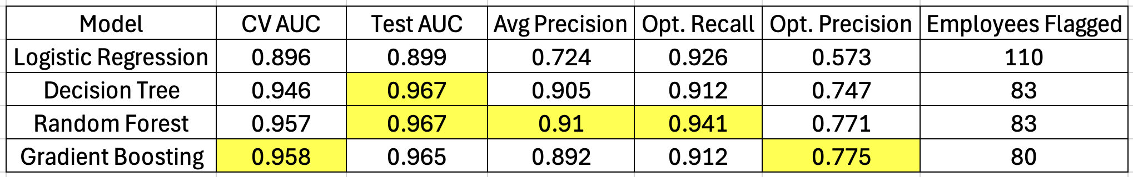

The highest scores are highlighted in yellow for each measurement. Our logistic regression model was clearly the weakest of the bunch as it ranked last in all measurements and also flagged the most employees, which will impact the efforts needed in our interventions. The other three models performed closely to each other but there are some nuanced differences between them.

Cross Validation and Test AUC scores were all above 94% for the Decision Tree, Random Forest, and Gradient Boosting models. However, our focus is on the Recall metrics to ensure we are prioritizing limiting the amount of false negatives because missing someone who needs outreach and support is our biggest concern. That being said, the highest Optimized Recall score comes from the Random Forest model which also had a solid Optimized Precision score and reasonable amount of employees flagged compared to the other models.

Clustering Results:
In addition to classification, we applied K-Means clustering to segment the workforce into groups based on similarities in demographics, work environment, and mental health perceptions. All non-numeric features were label-encoded, and feature values were standardized prior to clustering to ensure equal weighting in distance calculations. The elbow method was used to determine the optimal number of clusters, with the curve flattening at k = 4, indicating four distinct groups as a balance between granularity and interpretability.
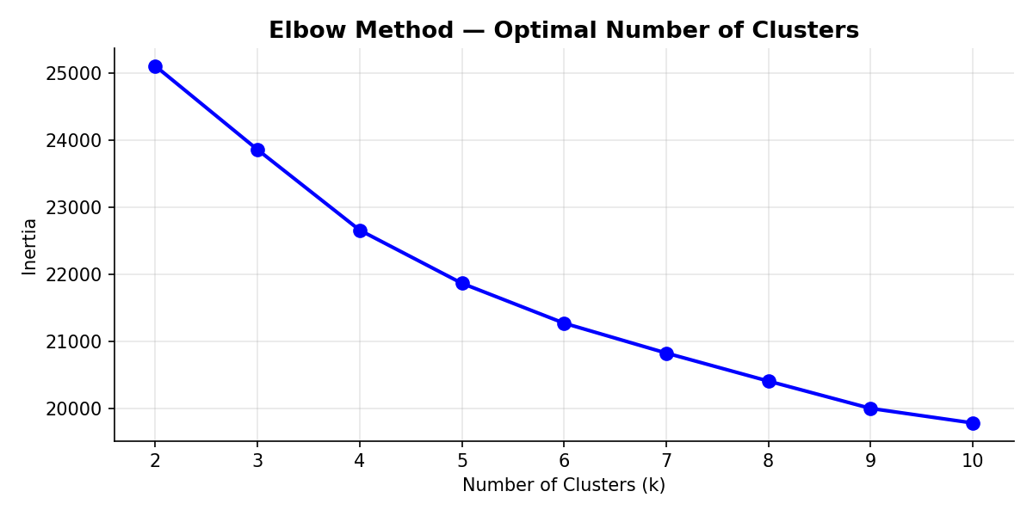
The four clusters were profiled to understand the characteristics and barriers to treatment-seeking for each group. Key cluster statistics are summarized below:
- Cluster 0: Supported & Engaged (n = 309)
High levels of treatment-seeking (68.6%), strong employer-provided benefits (83.2%), and high anonymity protection (72.2%). Most employees were on-site (82.5%) and reported moderate work interference (56.3%). This cluster reflects employees who are aware of, and supported by, workplace resources.
- Cluster 1: Unaware & Disengaged (n = 369)
Low treatment rate (36.6%) with minimal employer support (benefits 16.8%, seek_help 4.9%) and low anonymity protection (15.4%). This cluster largely comprises on-site employees (68%) who may be disengaged or unaware of available mental health resources.
- Cluster 2: Stigma-Sensitive (n = 434)
Moderate treatment-seeking (48.6%) but high fear of professional consequences (42.9%) and very low anonymity protection (8.3%). Employees in this cluster experience moderate work interference (48.4%) and limited employer support, suggesting stigma and perceived workplace risk as barriers to seeking care.
- Cluster 3: Isolated Remote Workers (n = 139)
Moderate treatment-seeking (53.2%) with low employer support (benefits 13.7%, seek_help 14.4%) but predominantly remote (71.2%). High levels of work interference (58.3%) indicate that isolation and lack of direct workplace engagement may contribute to underutilization of mental health resources.
A PCA visualization of the four clusters confirms separation and distinct profiles in reduced two-dimensional space. A comparative analysis of key metrics across clusters highlights significant differences in treatment rates, work interference, and perceived employer support, supporting a data-driven segmentation approach for targeted interventions.
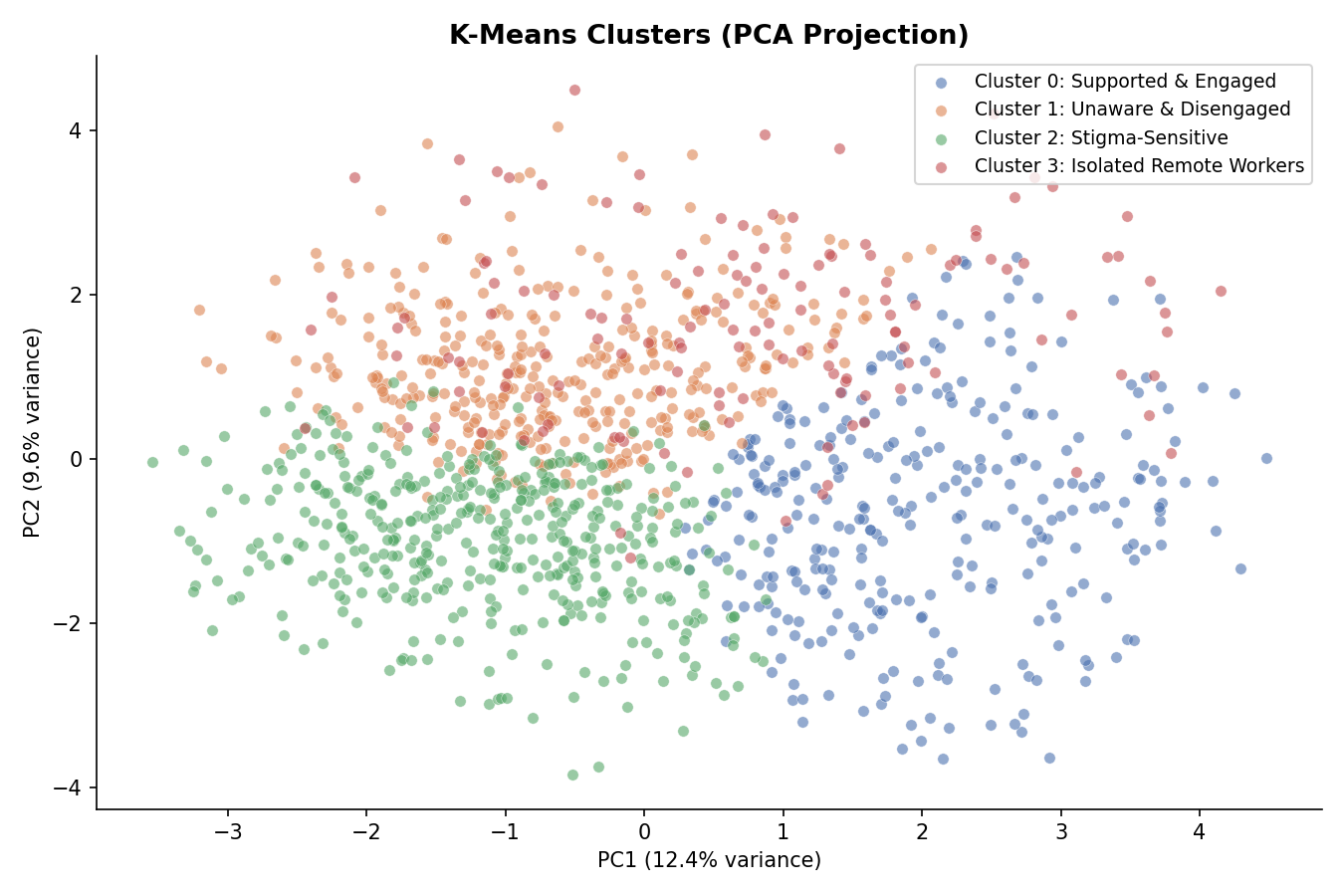

The cluster-based segmentation provides actionable insights for tailoring interventions to employee subgroups with distinct barriers, including stigma, lack of awareness, and remote work isolation. This complements the classification analysis by identifying groups of employees who may benefit from community- or group-level interventions, rather than individually-targeted approaches.

Proposed Interventions - Tania & Adil

Classification Intervention:

With these model outputs, we would recommend company-wide interventions to impact the entire employee population in a top down approach. Our audience for this intervention would be the decision makers in Human Resources (HR) and also the managers of any employees who had filled out the survey.

The two interventions we would recommend implementing would be an overall increase in the company’s mental health benefits and required sensitivity training for the managers whose employees were identified as having a mental health condition but not seeking help (the model output of 83 flagged employees). The first intervention would include working with the HR team to evaluate their current mental health benefits and suggest improvements to include offering EAP plans, offering mental health services through a digital vendor such as Lyra Health or Spring Health, and/or offering Mental Health days for employees to disconnect from their work. The exact recommendations would depend on the company’s current benefit offerings and would require more discussion with the HR department to determine which offerings are feasible for their company.

Secondly, we would use the model’s identification of employees who have mental health conditions but do not seek help to flag the managers of these employees and target them for required education training on mental health. This includes identifying signs of mental health issues, learning the best techniques to address these issues, and deciding when to intervene with an employee if they identify a severe mental health episode. Training could also be more vague and focus more on fostering a better work environment since many mental health issues arise from the environment they work in. Once again, these exact trainings and their frequency would have to be decided based on what is feasible for the company from discussions with HR.

The data pipeline of this would begin with the outputs of the employees survey which would be pushed into the production model. The model outputs would then be pushed into an internal Tableau dashboard for HR leaders to review the aggregated results. The dashboard would be leveraged for three main goals. First, HR leaders could review the responses from individuals who were flagged with the target variable and view all the responses from these individuals to determine if a pattern exists to develop better benefits around.

Secondly, this dashboard could also have a view that aggregates up to managers and directors to identify which areas of the company might have the most unaddressed mental health employee issues. This is where identification of who would need to take the required manager training. Thirdly, this dashboard could also trend these results over time as more survey data comes in. The effectiveness of this would be determined on how often the survey is offered, but the goal is that overtime you could determine if your interventions had any effect on overall responses on the survey. Below is a sample data pipeline to to support these ongoing interventions:

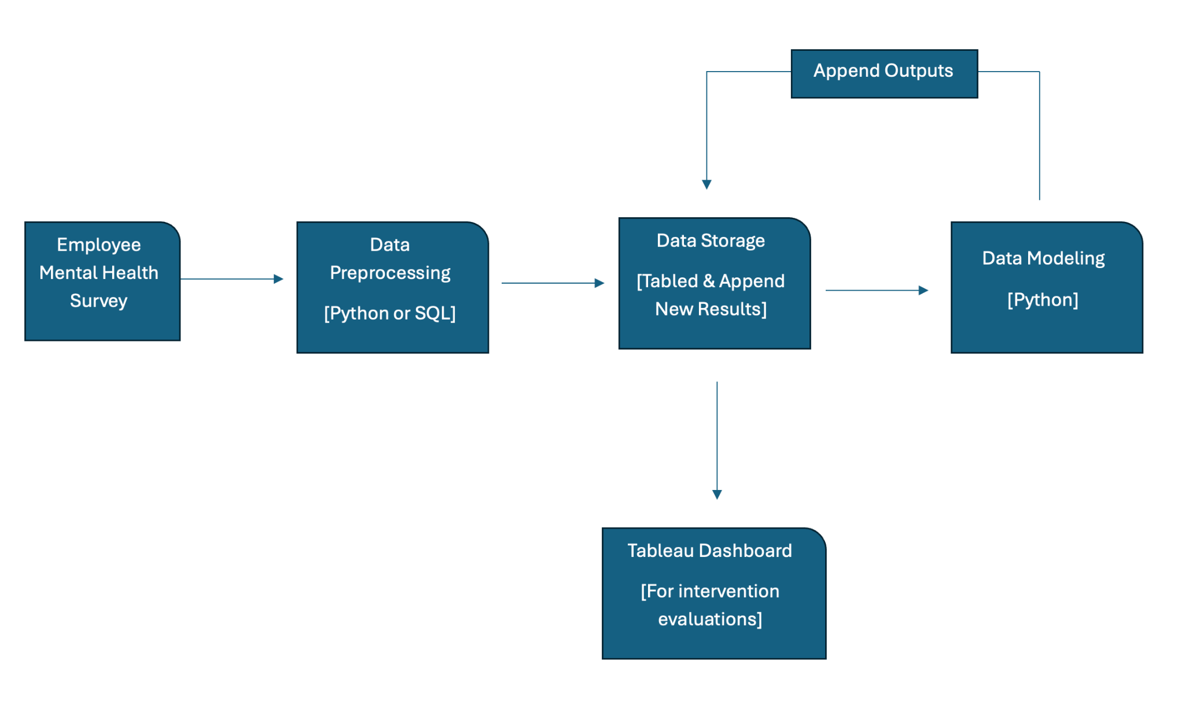

Clustering Intervention:
Using the K-Means clustering results, we propose interventions that are tailored to specific employee groups based on their mental health barriers, work environment, and benefit access. Unlike the classification intervention, which targets employees flagged as at-risk, the clustering approach allows HR to design targeted programs for each distinct group.
The primary audience for this intervention includes Human Resources (HR) leaders, managers, and team leads overseeing employees in each cluster. Interventions are designed to address the specific characteristics and challenges identified for each group.
Proposed Cluster-Specific Interventions:
- Supported & Engaged (Cluster 0):
  - Employees in this group already have high access to benefits and show engagement with mental health resources.
  - Interventions would focus on reinforcing positive behaviors through wellness programs, peer support initiatives, and continued access to mental health services. HR can monitor participation to ensure these employees remain supported and motivated.
- Unaware & Disengaged (Cluster 1):
  - This cluster exhibits low awareness and utilization of mental health resources.
  - Interventions would include targeted awareness campaigns, workshops on mental health literacy, and guidance on accessing company-provided benefits. Tracking engagement is key to improving utilization.
- Stigma-Sensitive (Cluster 2):
  - Employees are concerned about workplace consequences and confidentiality, resulting in low treatment-seeking behavior.
  - Interventions would provide confidential support options such as anonymous counseling, teletherapy, and manager training on reducing stigma and fostering a safe work environment.
- Isolated Remote Workers (Cluster 3):
  - These employees primarily work remotely, with limited access to benefits and peer support.
  - Interventions would focus on virtual mental health resources, remote peer groups, and proactive manager check-ins to reduce isolation and increase engagement.
Data Pipeline for Clustering Intervention:
- Survey Collection: Employees complete regular mental health surveys.
- Clustering Analysis: Survey responses are processed through K-Means to assign employees to one of the four clusters.
- Cluster Profiling: HR reviews cluster metrics, including treatment rates, work interference, and fear of consequences, to understand each group’s needs.
- Targeted Intervention Deployment: Interventions are implemented based on cluster-specific challenges and opportunities.
- Monitoring and Feedback: HR tracks engagement and outcomes for each cluster over time to evaluate effectiveness and adjust programs as necessary.
The process is illustrated in the flowchart below, which outlines how survey data is transformed into actionable interventions for each cluster. This data-driven approach ensures that mental health initiatives are personalized, scalable, and measurable, allowing the organization to efficiently allocate resources and maximize positive outcomes.

Conclusion - Adil

References:
- Taubman, D.S., Parikh, S.V. Understanding and Addressing Mental Health Disorders: a Workplace Imperative. Curr Psychiatry Rep 25, 455–463 (2023).
- National Institute of Mental Health. (n.d.). Mental illness. U.S. Department of Health and Human Services, National Institutes of Health. Retrieved [Month Day, Year], from
- Wu, A., Roemer, E. C., Kent, K. B., Ballard, D. W., & Goetzel, R. Z. (2021). Organizational best practices supporting mental health in the workplace. Journal of Occupational and Environmental Medicine, 63(12), e925–e931.
- Gulliver A, Griffiths KM, Christensen H. Perceived barriers and facilitators to mental health help-seeking in young people: A systematic review. BMC Psychiatry. 2010;10:113.
- Mahalik JR, Dagirmanjian F. Working-class men’s constructions of help-seeking when feeling depressed or sad. American Journal of Men’s Health. 2019;13(3).
- Mackenzie CS, Gekoski WL, Knox VJ. Age, gender, and the underutilization of mental health services: The influence of help-seeking attitudes. Aging & Mental Health. 2006;10(6):574-582.
- Mohamed AF, Isahak M, Awg Isa MZ, Nordin R. The effectiveness of workplace health promotion program in reducing work-related depression, anxiety and stress among manufacturing workers in Malaysia. International Archives of Occupational and Environmental Health. 2022;95(5):1113-1127
- Belita, E., Neil‑Sztramko, S. E., Seale, C., et al. Organizational interventions to support and promote the mental health of healthcare workers during pandemics and epidemics: a systematic review. BMC Health Services Research. 2025;25(731).
- Wagner, S. L., Koehn, C., White, M. I., et al. Mental health interventions in the workplace and work outcomes: a best‑evidence synthesis of systematic reviews. International Journal of Occupational and Environmental Medicine. 2016;7(1):1–14.
- Joyce, S., Modini, M., Christensen, H., Mykletun, A., Bryant, R., Mitchell, P. B., & Harvey, S. B. Workplace interventions for common mental disorders: a systematic meta‑review. Psychological Medicine. 2016;46(4):683–697.
- NIOSH/CDC. Supporting mental health in the workplace. NIOSH Science Bulletin. U.S. CDC. 2024.
- World Health Organization. Mental health at work: fact sheet. WHO. 2024.
- NICE (National Institute for Health and Care Excellence). Mental wellbeing at work: Guidelines. NICE Guideline No. 212. 2022.
- Vinson, D. W., Arcan, M., Niland, D‑P., & Delahunty, F. Towards sustainable workplace mental health: a novel approach to early intervention and support. (Preprint) 2024.
- Improving employee well‑being and effectiveness: systematic review and meta‑analysis of web‑based psychological interventions delivered in the workplace. Journal of Medical Internet Research. 2017;19(7):e271.
- Effectiveness and feasibility of workplace‑based mental health interventions for university academic staff: a systematic review. Int J Environ Res Public Health. 2025;22(12):1787.

--------------------- Final Paper Instructions below. Keeping here for reference —----------------------

The report will be written in the format of a paper, similar to the CDC HI-5 model. Should be about 8-10 pages long , single spaced. Pay attention to the below details, including what the "proposed intervention" should entail. Don't forget to include references (in scientific format), and include proper numbered in-text citations.
Final Report Structure
- Introduction
- Lit Review (5-6 sources on topic) – 3 per team member
- Datasets description (from Kaggle or elsewhere, to be analyzed)
- Data Analysis & Results (statistics, Machine Learning, etc.)
- Proposed Intervention (based on analysis)
- Conclusion (summary)

Proposed Intervention requirements
- Data-driven, based on analysis (not your opinion)
- Incorporate CDC’s HI-5 “three buckets” – what are the goals?
- Identify target audience - general public? specific age group or demographic? Patients vs clinicians/doctors?? (can have multiple target audiences)
- Plan to visualize data and communicate with Target Audience (e.g. dashboard)
- Data Engineering plan - to support ongoing intervention (e.g. data pipeline “design sketch”)

Links
- CDC HI-5 - https://www.cdc.gov/policy/hi5/index.html
- HI-5 Evidence Summaries - https://www.cdc.gov/policy/hi5/aboutsummaries/index.html
- Dallas County COVid19 example - https://www.himss.org/resources/dallas-county-public-health-disease-surveillance-and-investigation-system

Potential Dataset links:
- Kaggle datasets - https://www.kaggle.com/datasets
- UCI dataset repo - https://archive.ics.uci.edu/ml/datasets.html
- Google dataset search - https://toolbox.google.com/datasetsearch
- Government websites

CDC Population Health Competencies (focus on #1-7 for HDS Final Project):
- Assess the health status of populations using available data (e.g., public health surveillance data, vital statistics, registries, surveys, electronic health records and health plan claims data).
- Discuss the role of socioeconomic, environmental, cultural, and other population‐level determinants of health on the health status and health care of individuals and populations.
- Integrate emerging information on individuals’ biologic and genetic risk with population‐ level factors when deciding upon prevention and treatment options.
- Appraise the quality of the evidence of peer reviewed medical and public health literature and its implications at patient‐ and population‐ levels.
- Apply primary and secondary prevention strategies that improve the health of individuals and populations.
- Identify community assets and resources to improve the health of individuals and populations.
- Explain how community‐engagement strategies may be used to improve the health of communities and to contribute to the reduction of health disparities.

